SH34 User Manual
Version 1 - 13/03/2024
Overview
System Requirements
Installing the standalone package
Deploying the webapp
Building the docker image
Webapp user guide
Standalone package user guide
Known Issues
Troubleshooting
Table of Contents
Table of Contents 2
Overview 3
System Requirements 3
Web-app 3
Standalone Package 3
Installing the Standalone Package 3
Installing via Pip/vcs (recommended) 3
Installing Manually 3
Uninstalling 4
Deploying the Web-app 4
First Time Setup 4
Starting the Deployment 4
Stopping the Deployment 4
Building the Docker Image Manually (Advanced) 4
Web-app User Guide 5
Home Page 5
Template Page 6
Graph Editor 6
Standalone Package User Guide 7
Known Issues 8
1. Sorting Automatically Switches to Descending 8
2. Home Page Search Bar Doesn’t Work 8
3. Template Metadata Cannot Be Changed 8
4. Mutual Exclusion Data Loss Risk 8
5. Previews Constantly Refresh 8

Overview
The SH34 project is a web-app which facilitates managing templates and plots. A template is a collection of plots under a namespace. A plot is a graphical depiction of some underlying data. The software responsible for the generation of plots is independent from the web-app code. It can therefore be used in a standalone manner to generate plots based on a configuration file.

System Requirements
The web-app and standalone python package have different system requirements. Although both can run on low-end systems.

Web-app
The web-app can run on any operating system supporting Docker, such as Windows 10/11, Ubuntu and MacOS. The web-app requires docker to be installed. This can be done by following the installation guide on the Docker website. The webapp requires around 3GB of storage space for the Docker image and roughly 2GB of system memory to run.

Standalone Package
The standalone package only requires Python3. This can be installed by following the installation guide on the Python website. Please ensure that Pip is also installed as it is required to fetch the package. There are no memory or storage requirements for the standalone package.

Installing the Standalone Package
Please ensure that Python3 and Pip are installed locally before following the steps below.

Installing via Pip/vcs (recommended)
- Open a terminal/command prompt.
- Check that pip is installed. This can be done by running the following command
pip --version. If this fails, try pip3 --version. If pip3 worked and pip didn’t, from this point forward type pip3 instead of pip.
- Install the standalone package by running the following command pip install ‘git+https://github.com/mrjoe3012/sh34-main#egg=sh34&subdirectory=src’. This will fetch the setup instructions from the public repository and install the sh34 python package to your system.
- If this command fails, try installing by alternate means (see next section)

Installing Manually
Ensure that git is installed on your system. This can be done by following the installation guide on the git website.
- Open a terminal/command prompt.
- Check that pip is installed. This can be done by running the following command
pip --version. If this fails, try pip3 --version. If pip3 worked and pip didn’t, from this point forward type pip3 instead of pip.
- Check that git is installed. This can be done by running the following command git--version
- Clone the project code by running git clone https://github.com/mrjoe3012/sh34-main.git . This will create a new directory named ‘sh34-main’ in your working directory.
- Install the python package by running pip install sh34-main/src .

Uninstalling
Run pip uninstall sh34 to uninstall the python package from your system.

Deploying the Web-app
Ensure that Docker is installed on your system. This can be done by following the installation guide on the Docker webapp. If on Windows, ensure the ‘Docker Desktop’ program is running in the background.

First Time Setup
- Go to the Docker Hub website and create an account if you don’t already have one.
- Open a terminal/command prompt window.
- Login to docker by running the docker login command and providing your account details when requested.
- Pull the docker image by running docker pull joe3012/sh34:latest . This will require around 4GB of storage space.

Starting the Deployment
Type this command into a terminal/command prompt:
docker run -p 3000:3000 -p 7575:7575 -it joe3012/sh34:latest /root/startup.bash -d -c https://github.com/mrjoe3012/sh34-main.git

Stopping the Deployment
Stopping the deployment will erase all saved information in the database. The deployment can be stopped by holding LCtrl and then pressing B, then releasing both keys and typing kill-session followed by the return key, all while within the terminal in which it was started. Alternatively, the container can be shutdown from the Docker Desktop interface.

Building the Docker Image Manually (Advanced)
This should not need to be done under normal use. Follow these steps if you have made changes to the Dockerfile or are unable to pull the docker image from Docker Hub.
Ensure you have Docker and git installed on your system and that you are running a Linux-based operating system. Open a terminal and navigate to the directory in which the ‘sh34-main’ repository is located if you already have it. If not, clone it by running git clone https://github.com/mrjoe3012/sh34-main.git . Run the image build script by running the following command sh34-main/scripts/build_docker_image.bash -r https://github.com/mrjoe3012/sh34-main.git

Web-app User Guide

Home Page
The home page, displays all templates stored within the database. On this page, new templates can be added. Templates can be sorted by attributes and templates can be explored further by visiting their pages.
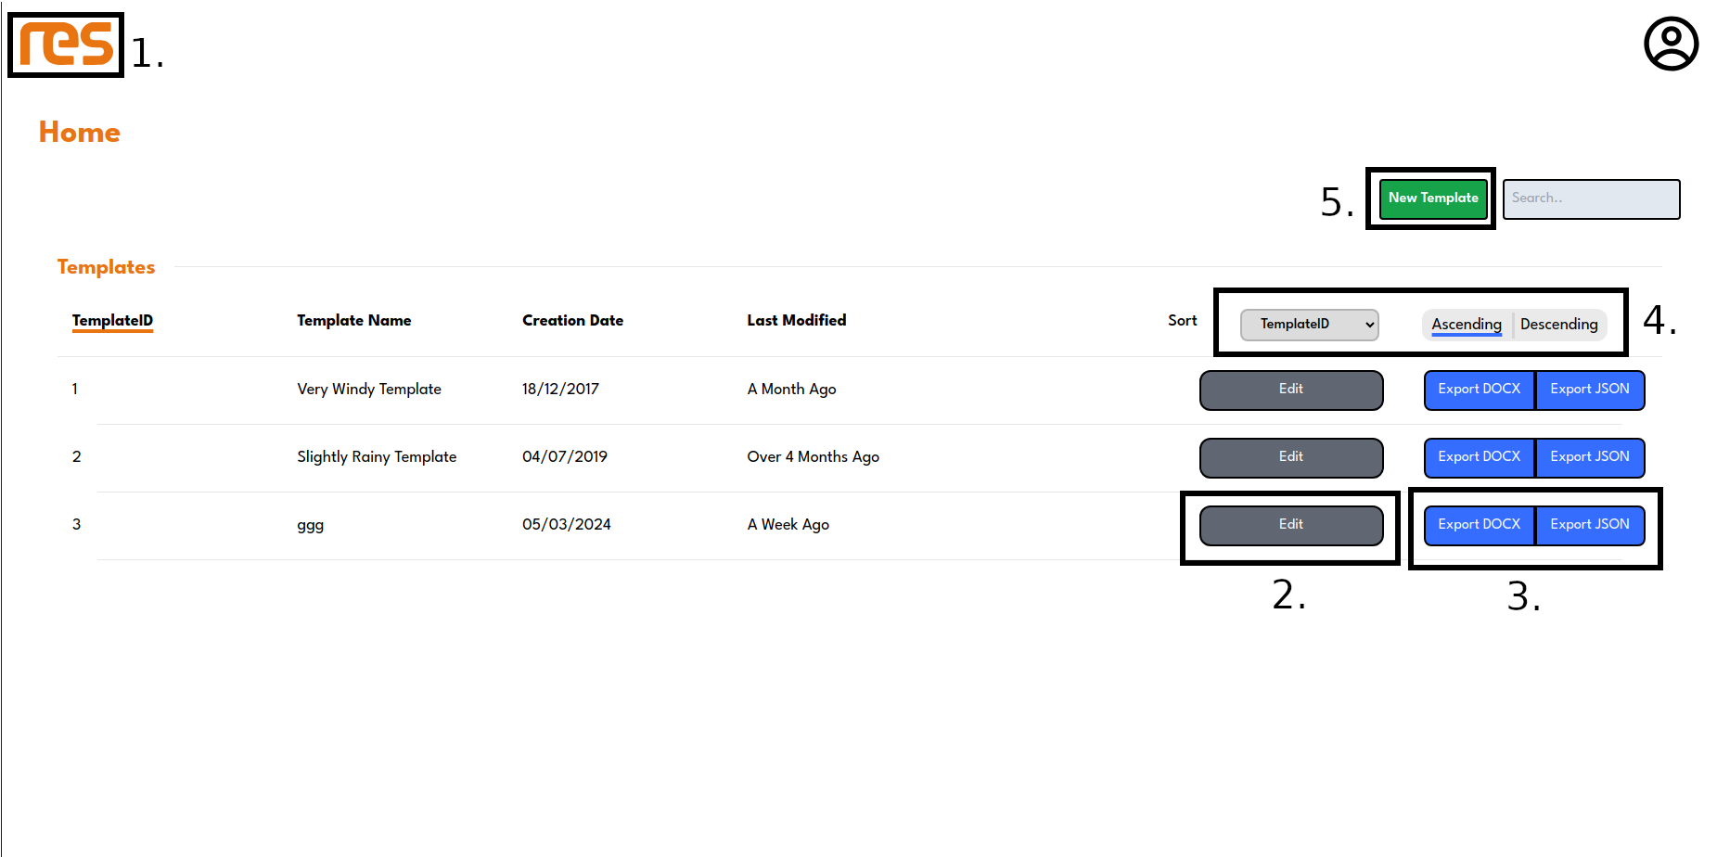Figure 1: Home Page
- The RES logo acts as a home button. This can be clicked at any time from any page in the site to return to the homepage
- The edit button takes you to the template page for a specific template. The template page is different for each template.
- The export buttons allow templates to be exported in two different formats.
  - Export DOCX: This renders the plots within the template as a DOCX file and downloads it to your computer
  - Export JSON: This downloads the underlying JSON configuration, which can be used in conjunction with the standalone package to generate plot images.
- Templates can be filtered by various attributes in ascending or descending order
- This button opens a dialogue for creating a new template and adding it to the database

Template Page
The template page displays all of the plots within a template. It is generated differently for each template, and so the page that is rendered depends on which ‘edit’ link was clicked on the homepage.

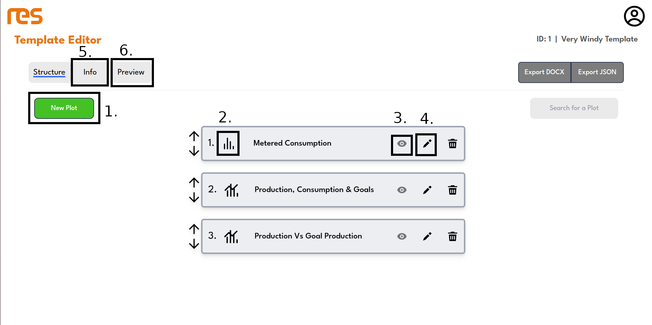Figure 2: Template Page
- The ‘new plot’ button opens a dialogue for adding a new plot to the current template.
- The plot indicator is displayed on each plot and represents the types of traces within the plot. Which can be pie charts, line graphs, bar graphs, scatter graphs or any combination these.
- The preview button allows for a plot to be rendered within the template page.
- The edit button takes the user to the graph editor for the corresponding plot.
- The info tab link changes the view to show the template’s metadata
- The preview tab takes the user to a structured preview of all plots within the template.

Graph Editor
The graph editor is generated differently for each plot. It contains features which allow a user to make changes to a plot’s configuration.
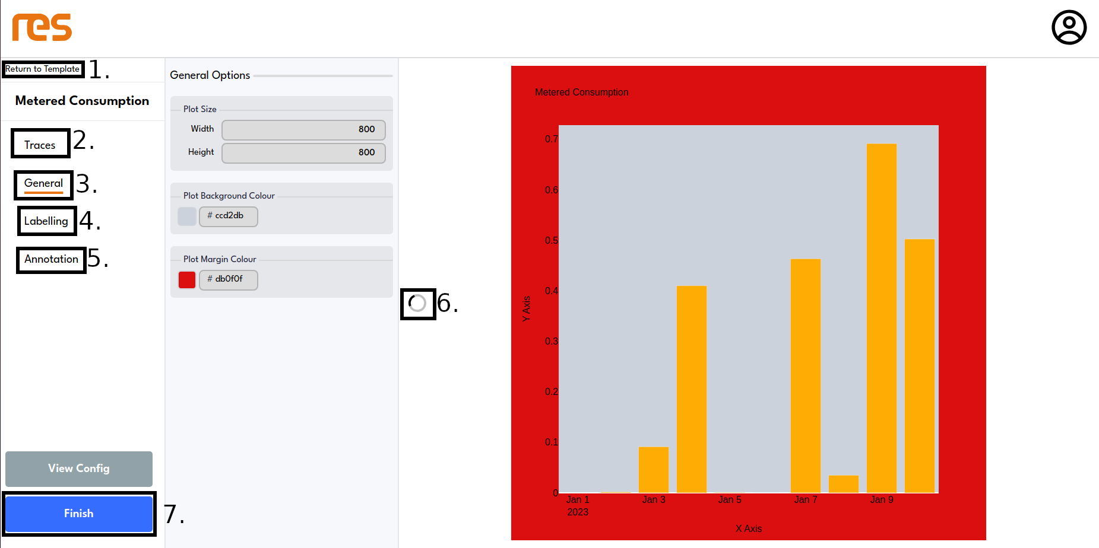Figure 3: Graph Editor
- This is a link which takes the user back to the template page for the template to which the current plot belongs to.
- The traces tab shows options related to adding and removing traces from the plot:
- adding a new trace (pie/scatter/line/bar)
- configuring data shown by trace
- modifying the colour of a trace
- modifying the name of a trace
- The general tab shows general options for a plot:
- changing the plot’s size in pixels
- modifying the background and foreground colours
- The labelling tab allows the user to modify label text and styles:
- title text
- axis labels
- axis ticks
- The annotation tab allows annotations to be added and removed from the plot. Annotations are text objects which are rendered on top of the rest of the plot.
- adding and deleting annotations
- modifying annotation text, position and colour

Standalone Package User Guide
The standalone package allows the user to generate plots from configuration files. These configuration files can be downloaded using the Web-app using the export JSON feature. Please ensure that the standalone package has been installed by following the guide in the Installing the Standalone Package section.
The executable takes two positional arguments:
- dataset: The path to the JSON dataset containing the information to be plotted
- config_file: The path to the JSON configuration containing one or more plot configurations
The program will the produce a PNG image for each plot configuration within the provided JSON file. An example execution would be sh34-standalone /home/joe/res_data.json /home/joe/plot_config.json.
A sample dataset can be obtained from the repository in src/fixed.json

Known Issues
Many features are yet to be implemented or are problematic. This section covers these issues.

1. Sorting Automatically Switches to Descending
Whenever sorting attributes are modified on the home page, the sorting order is automatically switched to descending. This is a bug.

2. Home Page Search Bar Doesn’t Work
The logic behind the search bar in the home page hasn’t been implemented. Data can be typed into it but the filter will not be applied.

3. Template Metadata Cannot Be Changed
In the template page under the Info tab, there are text fields containing the template’s metadata. Changing these fields does not update the database as this feature has not yet been implemented.

4. Mutual Exclusion Data Loss Risk
When a user attempts to access a resource that is already in use by another user, they will be locked out of the page. This can be problematic on the graph editor, as if user A is editing the graph and user B also attempts to access it, sees the error message and leaves their computer, when user A stops editing the graph user B’s browser session may be out of date and send an old version of the graph to the server.

5. Previews Constantly Refresh
Due to a recently added feature which constantly fetches data from the backend to make pages more dynamic, a refresh is triggered in previews as well which makes them buffer over and over again. This is a relatively simply fix that we unfortunately didn’t have enough time to complete.

